ROYAL OAK INTERNATIONAL SCHOOL
SR. SEC. CBSE AFFILIATED
HOLIDAY HOME WORK (SESSION 2018 - 19)
Class VI
Name ____________________ Roll No. __________ Sec._______
Please note the following :
- Summer vacations will commence from 17th May 2018(Thursday) till 29th June 2018(Friday) both days inclusive.
- The school will re-open on 2nd July, 2018(Monday)
- Schedule for the submission of HHW for all class is as follows :
English : 09/07/2018
Hindi : 10/07/2018
Maths : 11/07/2018
Science : 12/07/2018
SSt. : 13/07/2018
- For French, Computer, Gk, Sanskrit, Art & Craft (2nd week of july) dates will be given in the classes only by the subject teachers.
- Summer HHW -5marks will be added as an Activity marks in Term - I

WISHING YOU ALL A VERY FRUITFULL AND ENJOYABLE VACATION
HAPPY HOLIDAYS
Attached

Your holiday homework this year is combined with varied aspects of the language. It has been designed to ensure that you enjoy and learn at the same time.
English
Attached
Attached

Do your Holiday Homework in a separate thin notebook.
Do neat work and present it with an attractive cover page.
Be creative. Be innovative.
I. Read the novel ‘David Copperfield’ written by Charles Dickens.
a) Write the main characters you found.
b) Which character is very close to your heart and why?
c) Write a summary in about 100 words.
d) Find one anonym and one synonym for 10 new words you found in this part of the novel.
e) Present your work creatively.
II. As you already know that ‘Environment Day’ falls in the month of June. On the occasion of ‘Environment Day’, the school has decided to organize a visit to Science museum . Vikram, the secretary of the Science Society, wants to call a meeting of the office bearers of the society to discuss the arrangements for the fair. Write a notice in not more than 50 words.
III. Write a paragraph on the ‘Run for Health’ in which you participated with your friends.
IV. Prepare a creative and eye catchy noun chart with some examples on A3 size sheet.
V. Draw a web-chart and write down the values that YOU IMBIBE FROM A Banyan tree.
VI. Design an advertising pamphlet for an event to be organized on International day for disabled persons in your society. (You may choose the event, give it a catchy slogan with relevant details. Add a thought provoking message.)
Grammar
I. Fill in the blanks with a /an/ the . Put × where no article is necessary.
1. _____Tower of London is ____popular tourist attraction.
2. Newcastle is____ town in____ north of ____England.
3.____ Princess lives in____ palace in____ London.
4.____ Buckingham Palace is where____ Queen of England officially lives.
5. She bought____ expensive necklace at____ Harrods.
6. They went for____ stroll around ____St James' Park.
7. The supermarket is in____ Kendell Street opposite____ Lloyds Bank.
8.____ hotel where they held their wedding reception was called____ Grand Hotel.
9. Anna was born in ____Italy but she lives in___- U.S.A. now.

II. Fill in the blanks with appropriate Determiners.
1. Could you bring me _________ books I left in the garden?
2.______sun rises from the east.
3. The doctor advised me to eat _____apple every morning.
4. There aren't ______students in the library.
5. I haven't got ______ pictures in my bedroom.
6. She gave a cookie to ______ child.
7. I've got to solve ______ math problems before I go to sleep.
8. (With a bowl of cherries on your lap) ______cherries are delicious!
9. My mother doesn't drink ______coffee.
10. I always keep ______money in my wallet for emergencies.
III. Read the following sentences and state whether they are used transitively or intransitively.
1. She has written a novel.
2. Mitra teaches English as a municipal school.
3. I took a book from the library.
4. The sage smiled knowingly.
5. The boy sat on the bench.
6. She always carries an umbrella.
7. I answered only six questions.
8. I don’t know the answer.
9. I have finished my homework.
10. Have you eaten your lunch?

IV. Fill in the blanks wisely with the given pronouns.

It me That These This Those yours yourself

1.I'm in bed, because I'm ill. Looking through the window is my only fun. Look,______ are my friends
playing football in the playground.

2.That isn't Diana's house. ______ is next door.

3.“Hello. My name's Frank. What's______ ?”

4. ______is certainly not hot tea, l can touch it.

5. I've got a problem. Can you help ______?

6.______ is my father's picture on the wall. It's dirty, but I can't clean it, because it's too high.

7. My office isn't big. ______'s quite small.

8. You can do it by ______.

9. ______books are very interesting. Could I borrow them?

V. Look at the words and phrases below. Rearrange them to form meaningful sentences to make readable passage. Write the correct sentences in the space provided.
1. a very / Vidyasagar / and / was / man / generous / charitable
2. years he / from his / the poor / earliest / and the needy / of his power / to the utmost / helped
3. would nurse / if one / sit by / him and / his bed / of his school-fellows / fell ill he
4. hundreds of / when he / poor widows / grew rich / supported / and orphans / were / by him

VI. Do the exercises of Grammar Section in the book ‘Together with English’.

Determiners: Page no. C20, C30, C31
Noun: Page no. C4, C5
Pronoun: Page no. C14, C15, C16

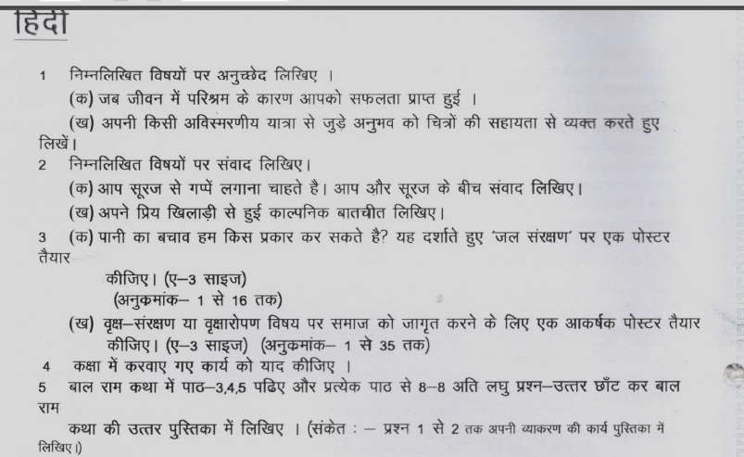
Maths
Prepare a small notebook and do the given work in it.
1.Do the given practice sums (Q157 to 170) from Exemplar
2.Do( Q1 to 24) & (99 to 134) in the Exemplar book only
2.Do the given worksheet
3.learn tables from 2-25.

Choose correct option
- 786643 _______ 785645
- > b) < c) = d) none of these
- 156781________ 267654
- < b) > c) = d) none of these
- What is 10000 – 1?
- 9 b) 99 c) 999 d) 9999
- What is the product of place values of 8 in ‘12868’?
- 80 b) 8 c) 800 d) 6400
- What is the product of 2346 and 120?
- 461100 b) 253200 c) 230000 d) None of these

Fill in the blanks
- Number name of 674734 in Indian system of numeration is __________________
- Difference between Place value and face value of 3 in ‘7396745’ is ___________________
- Expanded form of 7856345 is ___________________
- Number name of 3784567 in International system of numeration is--------
- Write the Hindu Arabic numerals:
- XCV = _______________ b) CLXXXII = _______________
- DLXIX = ______________ d) MDCIII= _______________
- Write the following in Roman numerals:
- 240 = _____________ b) 410 = _______________
- 94 =_______________ d) 1250 =________________
- Write the smallest natural and smallest whole number.
- Write the successor and prodecessor of:
- 675689 b) 23336457
- Write the three whole numbers occurring just before 90001.
- How many whole numbers are there between 54 and 75
- Name the property.
a) 19 +63 =63 +19 d) 20 x 30 = 30 x 20
b) 7 x ( 6 – 3 ) = 7 x 6 - 7 x 3 e) (68 x 4) x 20 = 68 x (4 x 20)
c) 12 x (50 + 15) = 12 x 50 + 12 x 15 f) (20 + 3) + 16 = 20 + (3 +16 )

Q17. Find the product using Distributive property:
(a) 838 × 105 (b) 71326 × 179 - 71326 ×79

Q18. Solve using suitable rearrangement:
(a) 8 × 391 × 125 (b) 2 × 1248 × 50 (c) 87 + 64 + 36 (d) 914 + 86 + 200

Q 19. Estimate the following nearest hundreds and nearest tens:
- 4886 – 524 2193 x 756

Q 20. Find using number line:
a) 4 + 5 b) 1+6 c) 8 – 3 d) 3 x 3

Word problems
Q21. The number of students in each class of a school is 35. The fee paid by each student is
Rs 2050 per month.If there are 40 classes in a school, what is the total fee collection in a
month?

Q 22. A student multiplied 1234 by 32 instead of multiplying by 23. By how much was his
answer greater than the correct answer?

Q23. Jai eats from a hotel which charges Rs 65 for lunch and Rs 45 for dinner. Find the
money he has to pay for seven days.

Q 24. A merchant had Rs. 88,592 with her. She placed an order for purchasing 50 radio sets at
Rs.1100 each. How much money will remain with her after the purchase?

Q25. A factory, on an average, manufactures 2,725 calculators a day. How many calculators did it produce in
the month of January 2006?

Science
I Fill in the blanks:
1. Materials that have lustre are usually called as ____________________.
2. Three examples of metals are ____________,_____________& ________________.
3. The gas which can dissolve in water is _________________.
4. Materials are grouped together on the basis of _____ and _________ in their properties.
5. Some metals lose their shine and often look dull because of the action of ______ and ______________ on them.
6. Based upon transparency, materials can be grouped as ______, _____ and ____________.
7. A substance which is used in making different objects is called _________________
8. The materials which occur in nature are called ________________________ materials.
9. . The materials made by man are called____________________materials.
10. The materials which have natural shine on their surface are called ____________

II Name the following:
1. Two liquids soluble in water_______________, ______________________
2. Two liquids insoluble in water_______________, ______________________
3. Two transparent objects_______________, ______________________
4. Two translucent objects_______________, ______________________
5. Two opaque objects_______________, ______________________
6. Two solids soluble in water_______________, ______________________
7. A liquid metal _____________________________
8. Two miscible liquids________________, ______________________
9. Two immiscible liquids ________________,__________________
10. Two soluble substances in water_________________, ___________________
III Write true or false :
1. Stones and nails float on water.
2. Cotton is soft while iron is hard.
3. We choose a material to make an object depending on its properties and the purpose for usage.
IV Distinguish between
1. soluble and insoluble substances.
2. Hard / soft
VI Answer the following questions:
1. Why do we need to group materials?
2. Name any four properties that can be used for sorting materials.
ACTIVITY: Prepare a diet chart on A3 sheet to provide balance diet to a 12 year old child. The diet chart should include food items which are not expensive and are commonly available in your area.

SOCIAL SCIENCE
- Prepare a Picture Album : Group A (roll no. 1 to 15 )
Different features of Indus Valley Civilization along with some details.
Project should include following features : The great bath ,The citadel ,Houses , Granaries , Drainage system , Upper and lower town.
Group B (roll no. 16 onwards )
Different features of The Great Emperor Ashoka along with some details.
Project should include following features : The Lion Capital , Important cities , Ashokan inscriptions , Ashokan Pillar , Dhamma
Must begin the project by including the following parameters :
- Cover page with your name , roll no, academic year.
- Acknowledgement ( giving credit to those who helped you in this project)
- Map related to the project
- Project overview ( brief idea about the project )
- Content sheet ( 8 to 10 with relevant photographs )
- Conclusion
- Bibliography ( the book you read and the website you visited for the project )
- Prepare standard Time Zone of the world on A4 sheet and paste it in your fair note book .
- Prepare complete syllabus for Periodic Assessment I .
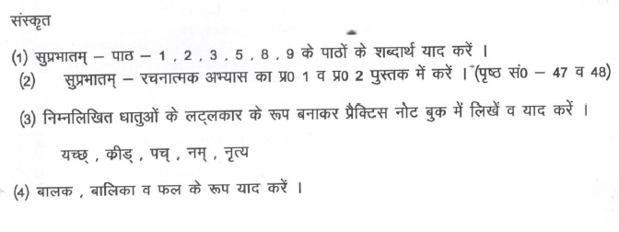

Computer
Roll No. (1 to 12):- Paste the picture of different types of Computers on a A4 sheet.
2) Roll No. (13 to 25):- Make a collages of different Output devices on a A4 sheet.
3) Roll No. (26 onwards):-Draw cell styles gallery refer Page no. 29 on aA4 sheet.
- Compulsory for all students: Draw this table in MS-Excel. Find out total and Result as pass or fail. Take printout of it.
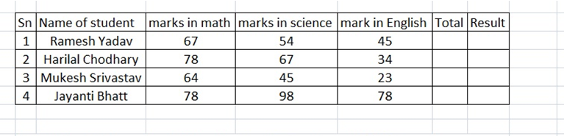
- Learn Lesson 1 and 2.

G.K
Read the newspaper daily and write two main important headlines every day, with one
Sports news and paste the related pictures in G.K. notebook. (From 1st June to 15th June 2018)

2. (a) Many systems of medicines like Ayurveda, Unani and Siddha make use of herbs to prepare medicines for curing diseases. On the basis of above fact paste 10 pictures of “Medicinal plants” on A3 size sheet and also mention their advantages. (Roll no. 1 to 15)

(b) Paste pictures of animals living under the ground on A3 size sheet and write few lines about each of them.
(Roll no. 16 onwards)

3. Personality development is a very broad term. It lays stress on manners, body language, the way we dress up, the way we communicate with other persons etc. One of the aspects of personality

Art/Craft
Summer Break : Photo frames use different material

French (FRANÇAIS)
OBJECTIF : CE DEVOIR CONTIENT QUATRE SECTION. LE BUT PRINCIPAL DERRIÈRE CE DEVOIR EST AUGMENTER LA CONNAISSANCE DES ÉLÈVES. IL AIDE AUSSI À AMÉLIORER LES COMPÉTENCES D'ÉCOUTE ET D’ÉCRITURE.
(PURPOSE : THIS ASSIGNMENT CONTAINS FOUR SECTION. THE MAIN GOAL BEHIND THIS ASSIGNMENT IS TO INCREASE STUDENT KNOWLEDGE. IT ALSO HELPS TO IMPROVE LISTENING AND WRITING SKILLS.)

LA SECTION CREATIF
(CREATIVE SECTION)

Q1. FAIRE UN COLLÈGE SUR N'IMPORTE QUEL SUJET CI-DESSOUS. (MAKE A COLLAGE ON ANY SUBJECT GIVEN BELOW)
  - LA FETE DE LA MUSIQUE. (MUSICAL FESTIVAL)
  - NOEL.(CHRISTMAS)
  - LA FETE DE LA MERE. (MOTHER’S DAY)
  - LA FETE NATIONALE.(NATIONAL FESTIVAL)
LA SECTION DE LECTURE
(READING SECTION)

Q2. LISEZDEUX HISTOIRES DES HISTOIRES DONNE CI-DESSOUS ET ÉCRIVEZ LA TRANSCRIPTION. (READ TWO STORIES FROM THE GIVEN LINKS AND WRITE THE TRANSCRIPTION OF ONE STORY ON A4 SIZE SHEET WITH BEAUTIFUL COVER )
  - https://www.thefrenchexperiment.com/stories/threepigs(LES TROIS PETITS COCHONS)
  - https://www.thefrenchexperiment.com/stories/goldilocks(BOUCLES D’OR ET LES TRIOS OURS)
  - https://www.thefrenchexperiment.com/stories/petitchaperonrouge( LE PETIT CHAPERON ROUGE)
  - https://www.thefrenchexperiment.com/stories/uglyduckling ( LE VILAIN CANETON)

LA SECTION D'ÉCOUTE
(LISTENING SECTION)

Q3. POUR L'ACTIVITÉ D'ÉCOUTE, VOUS POUVEZ SUIVRE LE SPECTACLE SUIVANT :
(FOR THE LISTENING ACTIVITY, YOU CAN FOLLOW THE FOLLOWING SHOW)
- PARLEZ MOI
- MATT L

